VAST spatial delta-GLMM Evaluation

# Background

Fishery-independent survey data represent one of the most important sources of information for stock assessment (Francis 2011, Methot et al. 2014). The NOAA-AFSC Groundfish Assessment Program conducts biennial bottom trawl surveys in the Gulf of Alaska and Aleutian Islands regions using a stratified random sample design, with effort allocated among strata based on observed catch rates, stratum variances, and stratum areas (von Szalay and Raring 2016). While design-based methods provide unbiased estimates of biomass for stratified random sample designs, a positive skew, wide tails, or a large number of zero observations (tows) can lead to unbiased but imprecise estimates of biomass (Thorson et al. 2011, Shelton et al. 2014). This is particularly problematic for patchily-distributed species whose non-uniform distributions in space result in large proportions of zero observations. Furthermore, design-based estimators assume uniform density within strata, ignoring information provided by the spatial correlation structure across sample locations.

Two alternative approaches to index standardization present potential opportunities to reduce uncertainty in biomass indices from GOA and AI bottom trawl survey data, and which may be more robust to reductions in sampling effort. The first is to model biomass observations as the joint probability of encounter probability and positive catch rates. Known within the fisheries literature as delta generalized linear mixed models (Stefansson 1996, Maunder and Punt 2004) and more generally as hurdle models (Ver Hoef and Jansen 2007), methods that model these two components of catch rate observations have been found to better partition variance and reduce uncertainty in survey indices. Delta generalized mixed models have found increased use for standardization of zero-inflated survey data in recent years, especially for US West Coast groundfish (Thorson and Ward 2014, Thorson et al. 2015a).

The second are geostatistical methods for modeling the correlation structure in biomass observations across space. Design-based estimators of biomass calculate average density within sampling strata, based on observed catches given area swept, and assume average biomass of a species within the pre-specified sampling stratum. As a result, variance among samples within a stratum result in an increase in the variance estimated for species biomass. However, Shelton et al. (2014) illustrated that for darkblotched rockfish (*Sebastes cramerai*) much of the variation in survey catches could be explained by spatially-correlated variability in habitat quality, and that accounting for the location of samples resulted in significant reductions in uncertainty for biomass indices derived from trawl survey data. In addition to increased precision of abundance indices for darkblotched rockfish, geostatistical model estimates did not have the spikes in abundance which had been deemed implausible for such a long-lived species (Gertseva and Thorson 2013).

Thorson et al. (2015a) developed a generalized maximum likelihood estimator for geostatistical index standardization, which approximate spatial and spatiotemporal variation in catch rates as Gaussian Markov random fields (Thorson et al. 2015b). When this geostatistical delta-glmm was applied to 28 groundfish species encountered in the U.S. West Coast trawl survey, estimation intervals from the conventional design-based approach were 60% larger on average than those derived from the geostatistical model-based estimator, but the trend and scale of resulting indices were generally consistent between methods (Thorson et al. 2015a). When applied to simulated data, Thorson et al. (2015a) found the geostatistical delta-glmm provided unbiased estimates of abundance, with well-calibrated confidence intervals that indicated greater precision than design-based estimators. Overall, the current body of research suggests that by modeling both encounter probability and positive catch rate probabilities together, and estimating spatial and spatiotemporal correlation, geostatistical delta-glmm’s are able to explain more of the variability in catch rate data, produce indices of abundance with greater precision than conventional design-based estimators, and may be able to use trawl survey data more efficiently.

# Purpose

A general platform for implementation of geostatistical delta-glmm for survey data is now available through the VAST (vector-autoregressive spatio-temporal) model package (Thorson and Barnett 2017), which is utilizes Template Model Builder (Kristensen et al. 2014) for estimation of fixed and random effects. Given the survey design for the NMFS Gulf of Alaska (GOA) and Aleutian Islands (AI) bottom trawl surveys, there is interest in exploring this geostatistical delta-glmm for model-based index standardization. However, prior to adopting these new methods it is necessary to compare current design-based indices with VAST model-based indices for a range of species (Table 1) with different life histories and spatial distributions, and evaluate sensitivity of model results to a range of specification options.

Table 1 Survey data included in the analysis of the geostatistical delta-glmm. Survey data for each species and region combination were evaluated separately.

|  |  |  |
| --- | --- | --- |
| Common Name | Scientific Name | Region |
| Arrowtooth flounder | *Atheresthes stomias* | Gulf of Alaska |
| Big skate | *Beringraja binoculata* | Gulf of Alaska |
| Dover sole | *Microstomus pacificus* | Gulf of Alaska |
| Harlequin rockfish | *Sebastes variegatus* | Gulf of Alaska |
| Northern rockfish | *Sebastes polyspinis* | Gulf of Alaska |
| Pacific cod | *Gadus macrocephalus* | Gulf of Alaska |
| Pacific ocean perch | *Sebastes alutus* | Gulf of Alaska |
| Spiny dogfish | *Squalus suckleyi* | Gulf of Alaska |
| Walleye pollock | *Gadus chalcogrammus* | Gulf of Alaska |
| Atka mackerel | *Pleurogrammus monopterygius* | Aleutian Islands |
| Northern rockfish | *Sebastes polyspinis* | Aleutian Islands |
| Pacific cod | *Gadus macrocephalus* | Aleutian Islands |
| Pacific ocean perch | *Sebastes alutus* | Aleutian Islands |
| Walleye pollock | *Gadus chalcogrammus* | Aleutian Islands |

VAST geostatistical delta-glmm’s were fit to NMFS/AFSC bottom trawl survey data for a range of species in the GOA and AI regions (Table 1), in order to address the following questions:

1. How do geostatistical delta-glmm (VAST) biomass indices compare with design-based estimates?
2. Does a geostatistical delta-glmm (VAST) approach to index standardization result in improved precision (lower estimation uncertainty) relative to current design-based estimators?
3. How does the level of spatial complexity (number of knots specified) influence the trend, scale, and uncertainty in resulting indices of abundance?
4. How does specification of autocorrelation in the intercept for encounter probability and positive catch rate components of the VAST model influence biomass indices?
5. How do estimates for apportionment across Gulf of Alaska regions compare between the current ADMB-RE model and alternative VAST model specifications?

# Model Specifications

Across all test cases some baseline model specifications were implemented:

* No random covariation in catchability was assumed (i.e. OverdispersionConfig).
* The observation model followed the standard delta model format with a logit link for encounter probability, lognormal distribution for positive catch rates (i.e. ObsModel).
* The bias correction option in VAST was turned OFF.

# GitHub

The VAST model software is available from Jim Thorson on Github at:

<https://github.com/James-Thorson/VAST>

Analyses and model comparisons described in this document are available at:

<https://github.com/curryc2/AFSC_VAST_Evaluation>

# Model and Design-based Comparison and Sensitivity to Specified Spatial Complexity

To compare the trend, scale, and precision of design-based indices with those from the geostatistical delta-glmm alternative, single-species VAST models were fit to available survey data for a range of species encountered in the GOA and AI surveys (Table 1). In addition, given that previous VAST models for GOA Northern Rockfish indicated sensitivity of resulting model-based indices to the level of spatial complexity assumed, alternative VAST models were fit to these data that spanned this continuum.

The knot number in a VAST model specifies the level of spatial complexity (Figure 1). For a given number of knots specified by the user (n_x), the k-means algorithm identifies the optimal location of these knots that minimizes the total distance between available data (tows) and the location of the nearest knot (Thorson et al. 2015a). Vast models were fit which fit with knot numbers ranging from 100 to 1,000.



Figure 1. Example from of how the knot number specification influences the level of spatial complexity within a VAST model, from GOA Northern Rockfish.

Comparison of current design-based indices from GOA and AI bottom trawl surveys, with geostatistical delta-glmm (VAST) indices, indicates that differences in scale, trend, and uncertainty vary among species and regions. For the GOA survey, VAST model-based indices differed from current design-based estimates, with the exception of Big Skate (Figure 2). For northern rockfish and harlequin rockfish, VAST indices did not exhibit the high variation between surveys, which had been deemed unrealistic given the life history of these species. Results were similar for spiny dogfish, with VAST indices both lower and less variable than current design-based estimates (Figure 2). VAST indices for Pacific cod and Big skate had both a similar trend and scale, when compared with design-based estimates. The scale of VAST indices were higher than design-based estimates for Pacific ocean perch, Walleye pollock, Dover sole, and Arrowtooth flounder, however the trend was generally consistent for most of these species. Beginning in 2003, VAST indices increase rapidly relative to design-based estimates for this stock.

Comparison of the uncertainty (CV) in biomass indices between model-based (VAST) and current design-based methods for the GOA indicated that for most species model-based estimates have greater precision (lower CV’s) across years (Figure 3). Table 2 displays the average percent difference in the uncertainty (CV) estimated for model-based (VAST) and design-based estimators, across years. While index CV’s are on average lower across species and knot specifications (i.e. negative percent change), increases in index precision are greatest for Pacific ocean perch, Pacific cod, Northern rockfish, Harlequin rockfish, and Spiny dogfish. Generally across species, the median level of index uncertainty (CV) appears insensitive to different knot number specifications, suggesting that increased spatial complexity does not significantly increase index precision.

Comparison of VAST and design-based indices for species captured in the Aleutian Islands survey indicated important differences from Gulf of Alaska. Model-based (VAST) indices were on average higher in scale, relative to current design-based indices (Figure 4). Across all levels of spatial complexity (knot number specification), model-based indices of biomass were substantially higher for the Aleutian Islands Pacific ocean perch. Contrary to results for the GOA survey, the level of estimation uncertainty (CV) for model-based (VAST) indices is not consistently lower than that for the current design-based indices (Figure 5). For Aleutian Islands Pacific ocean perch and Atka mackerel, index uncertainty is on average lower for the design-based estimator (Table 3). While it is unclear what aspect of the survey design or spatial orientation causes the difference, for the species compared it appears that for the GOA survey the model-based (VAST) estimator has greater precision compared with the design-based estimator currently used, while in this is not consistently true for the AI survey.

The level of spatial complexity assumed in the VAST model appears to have a similar influence on the scale of indices for both GOA and AI surveys. In general across species the scale of VAST indices appears negatively correlated with spatial complexity. While the magnitude of differences in index values between knot number specifications varies across species, it seems that generally as the specified number of knots increases, the scale of the biomass index decreases (Figures 2 and 4). However, the trend in VAST indices is generally consistent across different levels of spatial complexity. This result may be driven in part by the principle that as the specified level of spatial complexity decreases within the geostatistical model, estimated biomass density levels must be extrapolated over progressively larger areas. For patchily-distributed species this would result in high biomass density being extrapolated over artificially large areas, thus inflating overall biomass indices (See Figure 1 for an example).

## Gulf of Alaska Bottom Trawl Survey

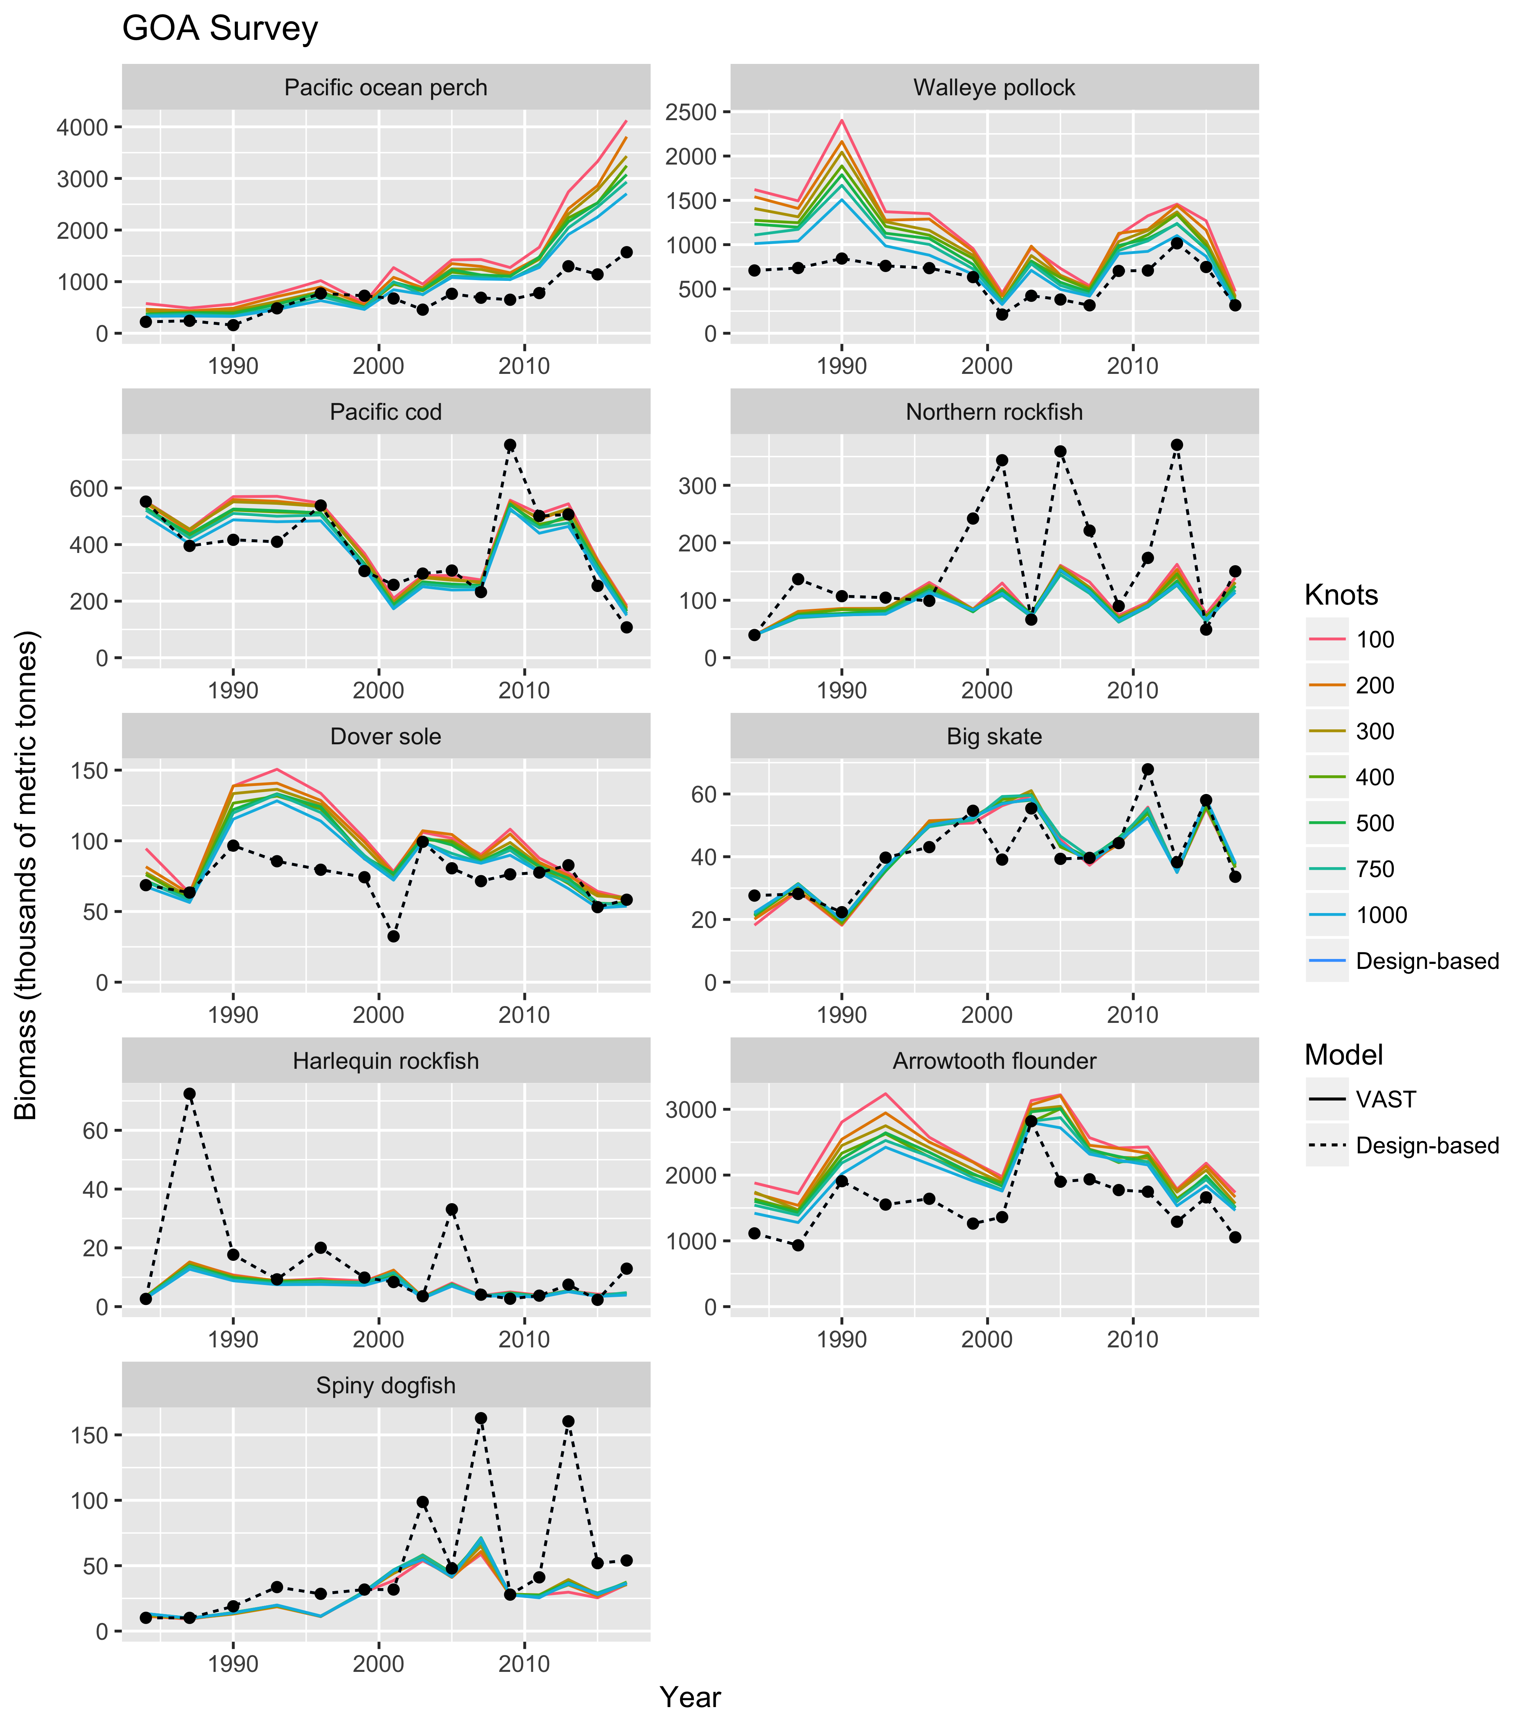

Figure 2. Comparison of annual survey biomass index estimates across species, models, and VAST knot number specifications, for the Gulf of Alaska bottom trawl survey. Model-based (VAST) indices are solid lines, while current design-based indices are dashed lines.

*Note: Figure only includes estimates for survey years.

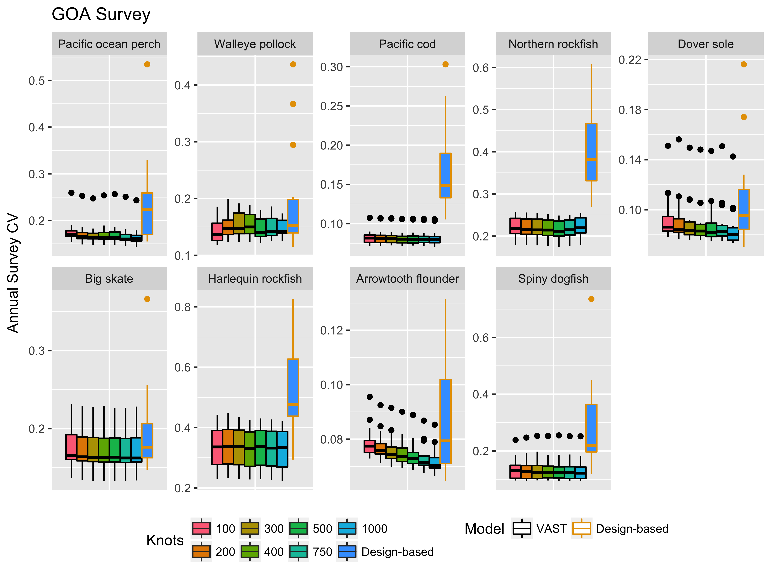

Figure 3. Comparison of index uncertainty (CV) across species, model types, and VAST knot number specifications, for the Gulf of Alaska bottom trawl survey. Each boxplot describes the distribution of estimated CV’s across survey years.

Table 2. Average percent difference between VAST (model-based) index uncertainty (CV) and design-based index uncertainty (CV), for the Gulf of Alaska bottom trawl survey.

|  |  |  |  |  |  |  |  |
| --- | --- | --- | --- | --- | --- | --- | --- |
| Species | VAST Model Knot Specification (n_x) | | | | | | |
|  | **100** | **200** | **300** | **400** | **500** | **750** | **1000** |
| Pacific ocean perch | -18% | -20% | -21% | -20% | -21% | -22% | -23% |
| Walleye pollock | -15% | -9% | -9% | -8% | -13% | -11% | -12% |
| Pacific cod | -46% | -46% | -46% | -46% | -47% | -47% | -47% |
| Northern rockfish | -43% | -43% | -44% | -44% | -45% | -44% | -43% |
| Dover sole | -8% | -9% | -11% | -12% | -12% | -12% | -15% |
| Big skate | -7% | -8% | -8% | -9% | -9% | -9% | -9% |
| Harlequin rockfish | -32% | -31% | -32% | -33% | -32% | -33% | -33% |
| Arrowtooth flounder | -6% | -8% | -9% | -10% | -11% | -13% | -14% |
| Spiny dogfish | -46% | -46% | -45% | -45% | -46% | -46% | -47% |

## Aleutian Islands Bottom Trawl Survey

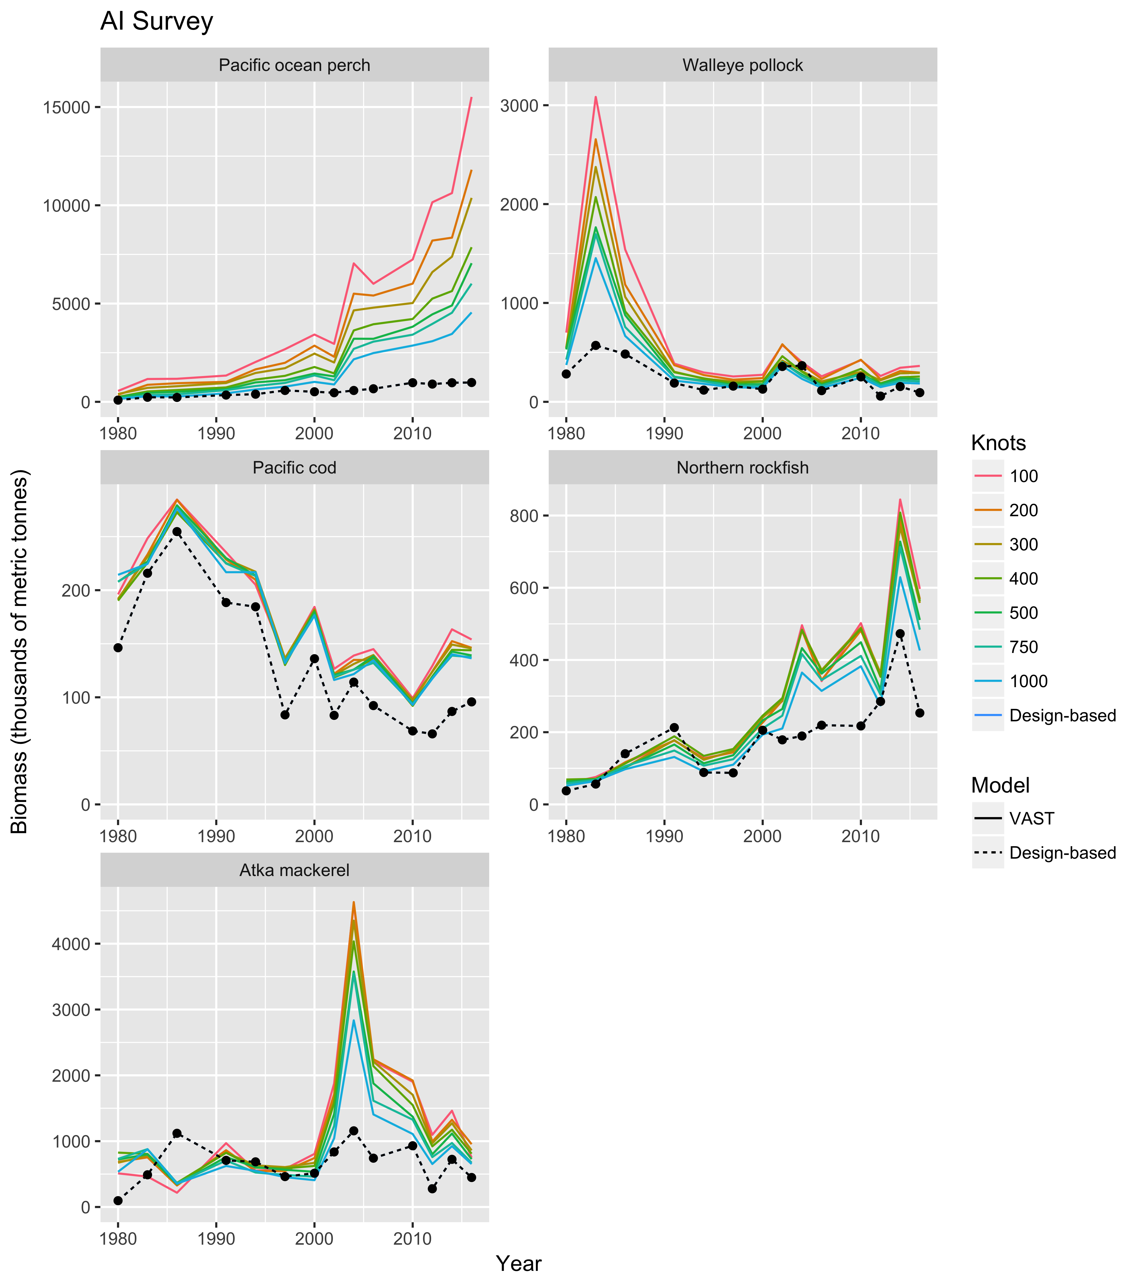

Figure 4. Comparison of survey biomass index estimates across species, models, and VAST knot number specifications, for the Aleutian Islands bottom trawl survey. Model-based (VAST) indices are solid lines, while current design-based indices are dashed lines.

*Note: Figure only includes estimates for survey years.

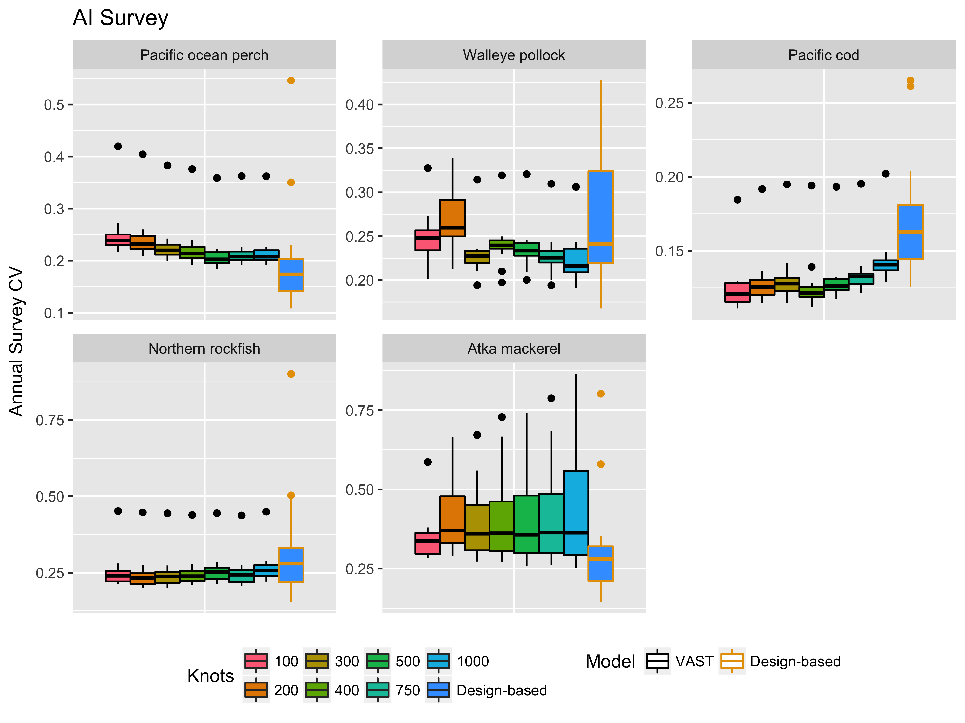

Figure 5. Comparison of index uncertainty (CV) across species, model types, and VAST knot number specifications, for the Aleutian Islands bottom trawl survey. Each boxplot describes the distribution of estimated CV’s across survey years.

Table 3. Average percent difference between VAST (model-based) index uncertainty (CV) and design-based index uncertainty (CV), for the Aleutian Islands bottom trawl survey.

|  |  |  |  |  |  |  |  |
| --- | --- | --- | --- | --- | --- | --- | --- |
| Species | VAST Model Knot Specification (n_x) | | | | | | |
|  | **100** | **200** | **300** | **400** | **500** | **750** | **1000** |
| Pacific ocean perch | 40% | 35% | 28% | 25% | 18% | 22% | 22% |
| Walleye pollock | -1% | 7% | -9% | -4% | -6% | -9% | -11% |
| Pacific cod | -25% | -22% | -21% | -24% | -22% | -19% | -14% |
| Northern rockfish | -8% | -11% | -9% | -8% | -4% | -7% | -1% |
| Atka mackerel | 29% | 50% | 48% | 49% | 49% | 52% | 58% |

# Comparison of Intercept Specifications for Encounter Probability and Positive Catch Rate

The VAST (vector-autoregressive spatio-temporal) model software (Thorson and Barnett 2017) allows specification of temporal autocorrelation in the average value (intercepts) of both the encounter probability and positive catch rate components of the model (i.e. RhoConfig[1:2]). These intercepts ($β_{t}$) represent the average encounter probability and positive catch rate across space, for a given species in a given year. The base VAST specification estimates the two intercepts are fixed effects, however they can be estimated to follow a random walk (Eq. 1) over time or be lag-1 autoregressive (Eq. 2).

(1) $β_{t+1}\sim Normal\left(β_{t},σ_{β}^{2}\right)$

(2) $β_{t+1}\sim Normal\left({ρ_{β}*β}_{t},σ_{β}^{2}\right)$

One question highlighted by the working group, was whether the assumption of autocorrelation in these two intercepts significantly influenced the estimated index for years with available survey data.

To evaluate sensitivity of the geostatistical index to autocorrelation specifications for the encounter probability and positive catch rate intercepts, single-species VAST models were fit to GOA and AI survey data for the same range of species (Table 1). All combinations fixed-effect (base) and autocorrelation specification were explored (Table 4).

Table 4. Notation for VAST model intercept (RhoConfig[1:2]) specifications.

|  |  |  |
| --- | --- | --- |
| Rho_Intercept Notation | Encounter Probability | Positive Catch Rate |
| FE | Fixed effect | Fixed effect |
| RW-FE | Random walk | Fixed effect |
| FE-RW | Fixed effect | Random walk |
| RW | Random walk | Random walk |
| AR-FE | Autoregressive (lag-1) | Fixed effect |
| FE-AR | Fixed effect | Autoregressive (lag-1) |
| AR | Autoregressive (lag-1) | Autoregressive (lag-1) |

Results indicate that the scale and trend in VAST (model-based) indices for survey years are fairly insensitive to whether or not the intercepts are fixed effects or correlated in time, for both GOA (Figures 6 and 7) and AI (Figure 8) survey data. Higher inter-survey variation in estimated biomass is observed for GOA Northern rockfish and Harlequin rockfish, when the intercept for positive catch rate is not correlated over time (FE, RW-FE, and AR-FE; Figure 6).

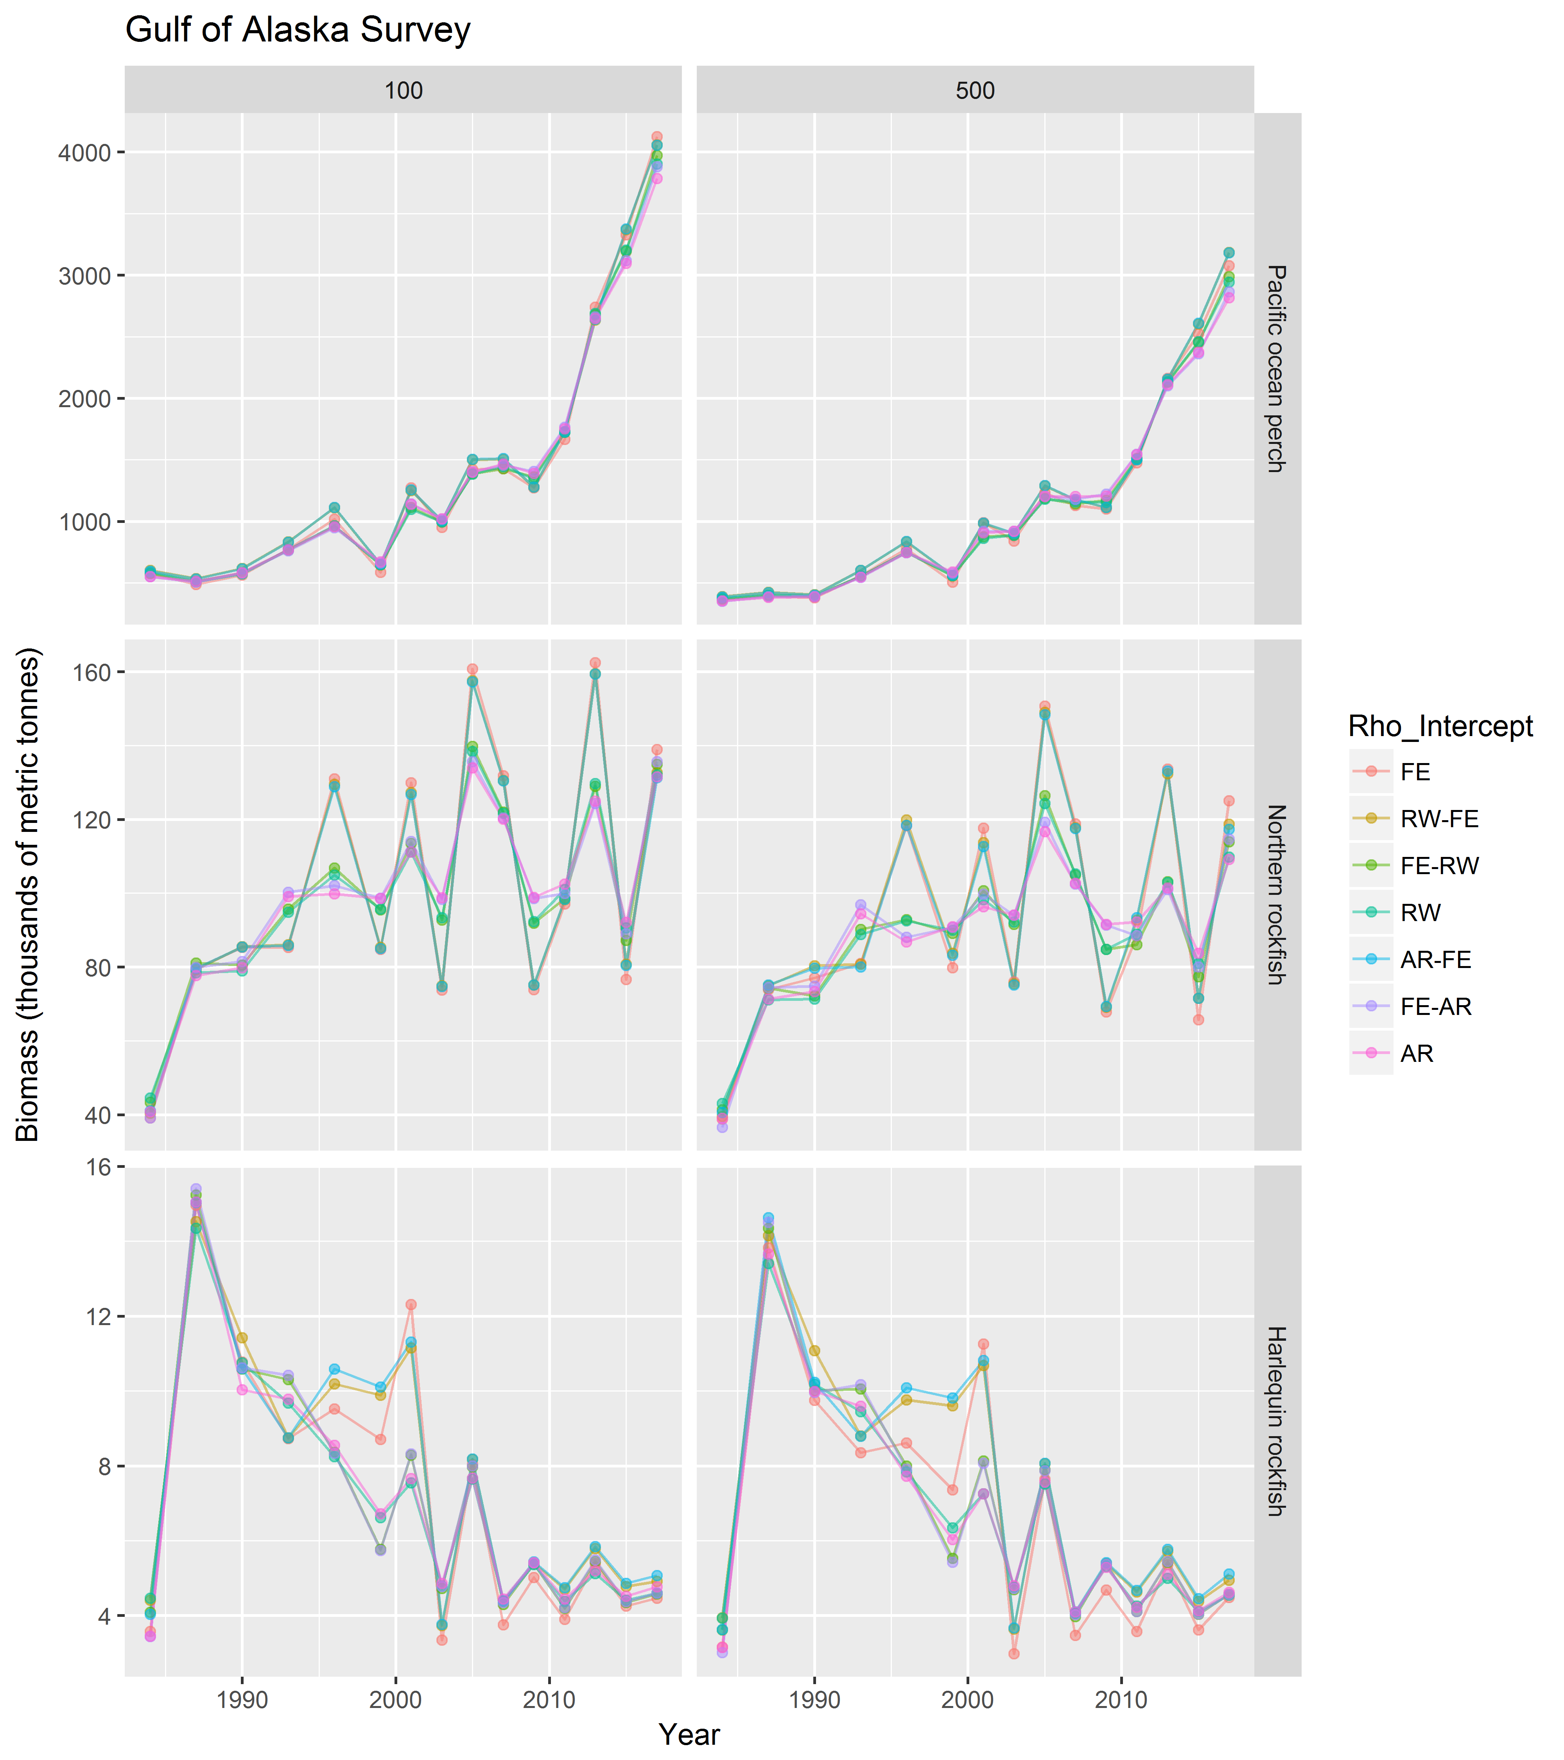

Figure 6. Comparison of VAST (model-based) indices for Gulf of Alaska rockfish species across encounter probability and positive catch rate intercept autocorrelation specifications, and knot number (columns).

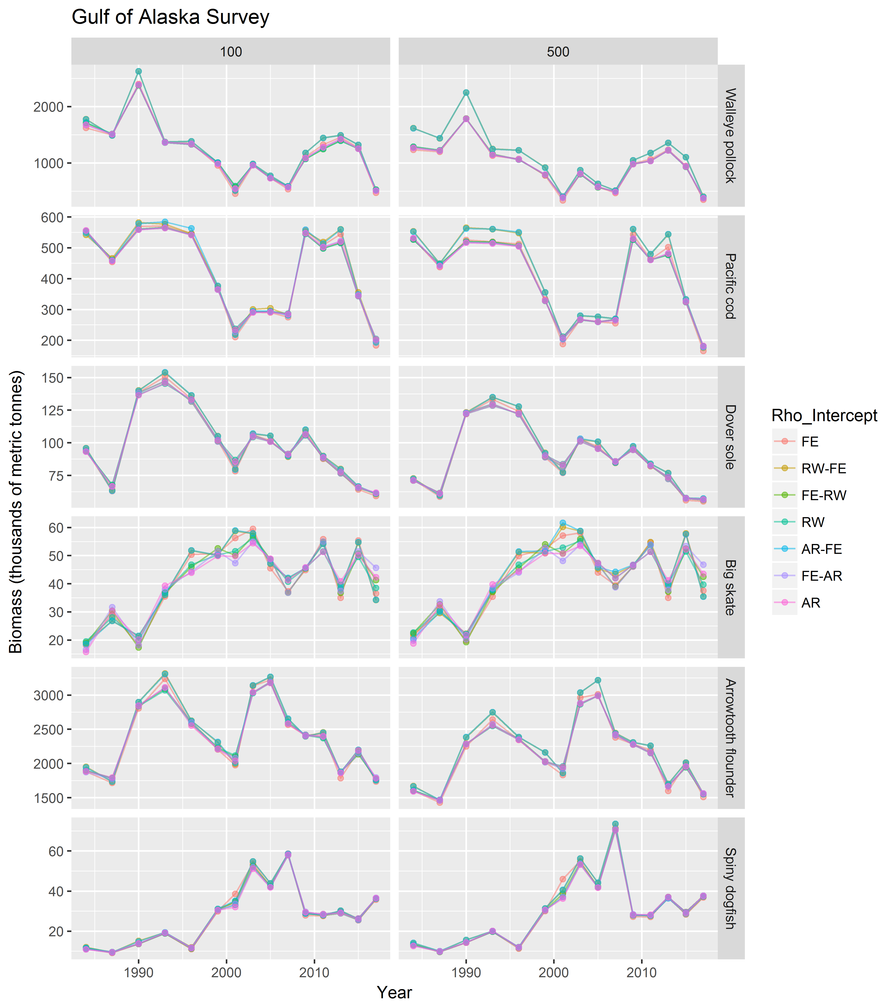

Figure 7. Comparison of VAST (model-based) indices for Gulf of Alaska non-rockfish species across encounter probability and positive catch rate intercept autocorrelation specifications, and knot number (columns).

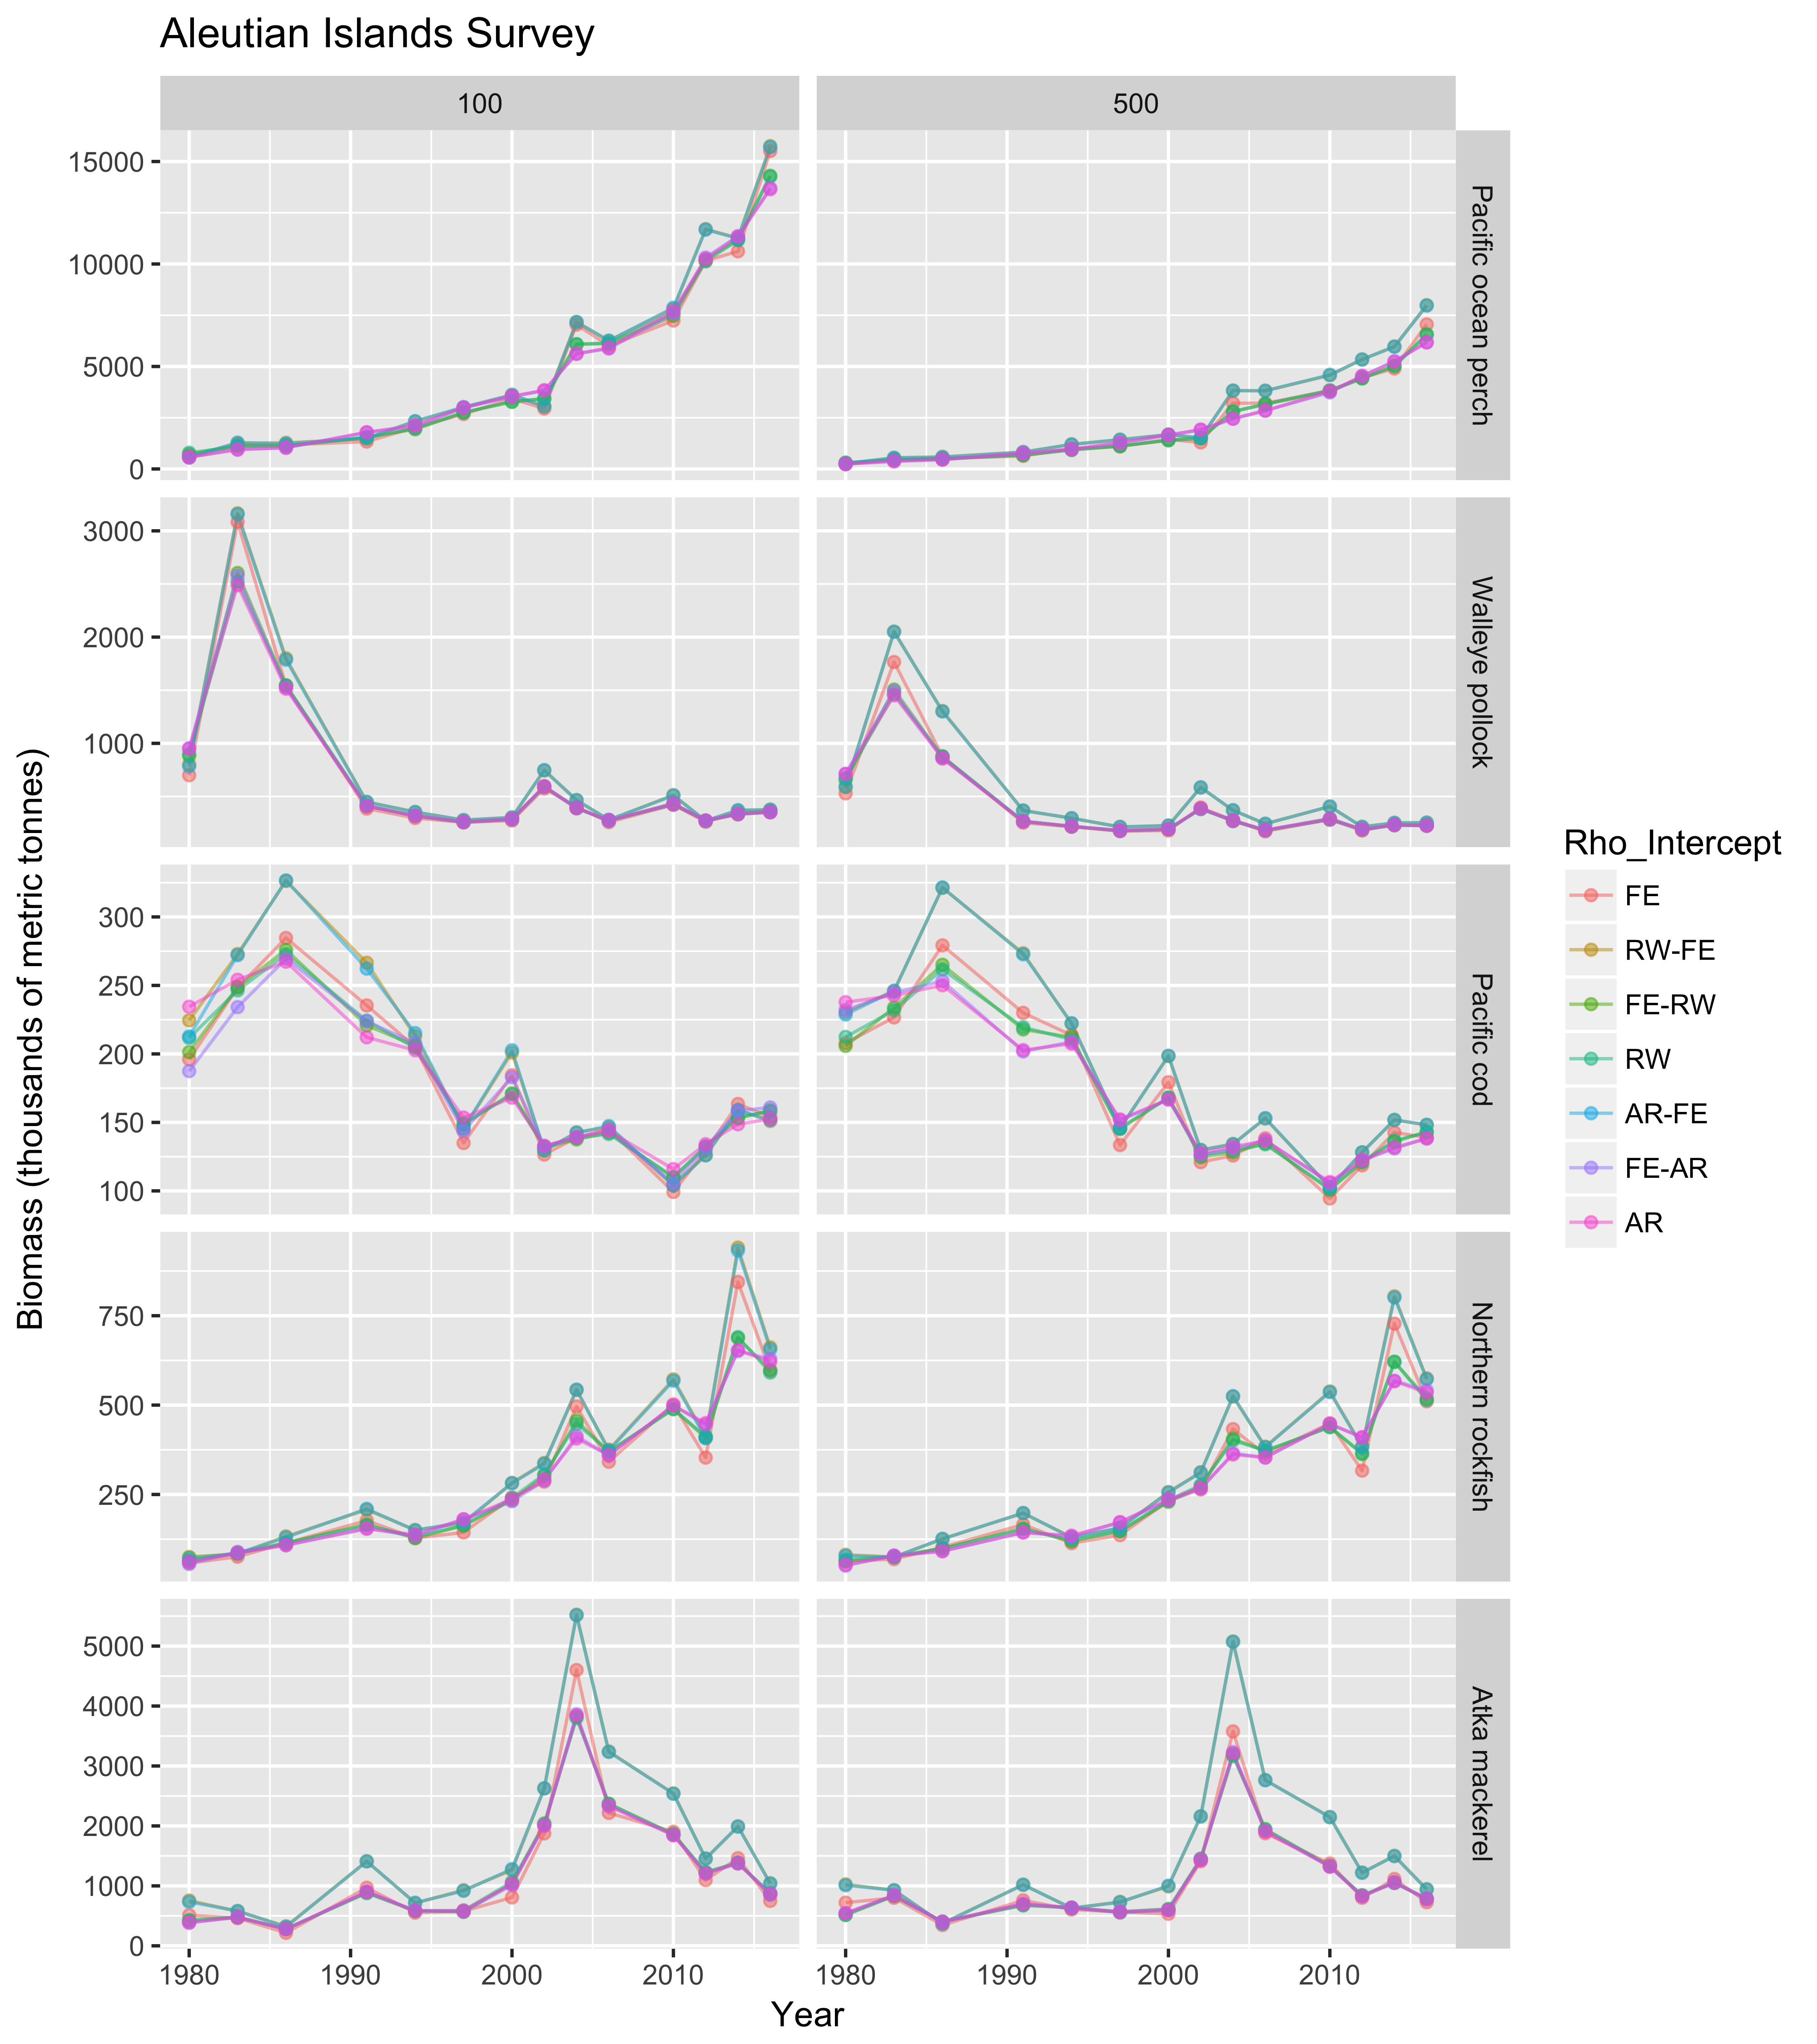

Figure 8. Comparison of VAST (model-based) indices for Aleutian Islands species across encounter probability and positive catch rate intercept autocorrelation specifications, and knot number (columns).

# Gulf of Alaska Apportionment Comparison

Evaluating the use of area-stratified VAST models for apportionment calculations has been highlighted as an important area of inquiry. Within the Gulf of Alaska, estimates of index apportionment between the Western, Central, and Eastern regions were compared between the stratified VAST model and the ADMB-RE model currently used. Inputs for the ADMB-RE model were separate design-based indices generated for the Western, Central, and Eastern GOA, and the ADMB-RE model assumed separate process errors for each index. Apportionment estimates were compared with VAST models parameterized with different temporal autocorrelation in intercepts and spatio-temporal random effects, and with or without spatial random effects. In all cases and contrary to the previous analysis, intercepts or spatio-temporal random effects were specified the same for both encounter probability and positive catch rate components (Table 5). All VAST models assumed n_x=250 knots.

Table 5. Specifications for temporal autocorrelation in intercepts (RhoConfig[1:2]) and spatio-temporal random effects (RhoConfig[3:4]) in alternative VAST model configurations. Note: In a given configuration both encounter probability and positive catch rate intercepts, or spatio-temporal random effects, had the same autocorrelation specification.

|  |  |  |
| --- | --- | --- |
| Notation | Intercepts | Spatio-temporal Random Effects |
| RW + IaY | Random walk | Independent among years |
| AR + IaY | Autoregressive (lag-1) | Independent among years |
| RW + AR | Random walk | Autoregressive (lag-1) |
| AR + RW | Autoregressive (lag-1) | Random walk |

Apportionment estimates from the VAST model for GOA rockfish species, and specifically Harlequin rockfish, were much less variable across years compared with ADMB-RE estimates (Figure 9). For all species, apportionment estimates from VAST models with autoregressive intercepts and spatio-temporal random effects specified as random walks (AR+RW), appeared to better capture the long term trends in relative biomass between the three regions which were estimated by the ADMB-RE model (Figures 9, 10, and 11). Estimates from the other VAST model specifications (RW+IaY, AR+IaY, and RW+AR), did not appear to capture the same long-term trends estimated by the ADMB-RE and AR+RW models, and exhibited higher interannual variation than did the AR+RW model.

Across species and model specifications, when spatial random effects were not estimated (bottom panels; Figures 9, 10, and 11) larger interannual variation in apportionment estimates were observed. The difference between apportionment estimates with or without spatial random effects, was less visible when intercepts were specified as autoregressive and spatio-temporal random effects as random walks (AR+RW). Overall, it appears that the AR+RW geostatistical model provides apportionment estimates most consistent with the current ADMB-RE model, and may provide some benefit in reducing interannual variation in apportionment recommendations for rockfish species (Figure 9).

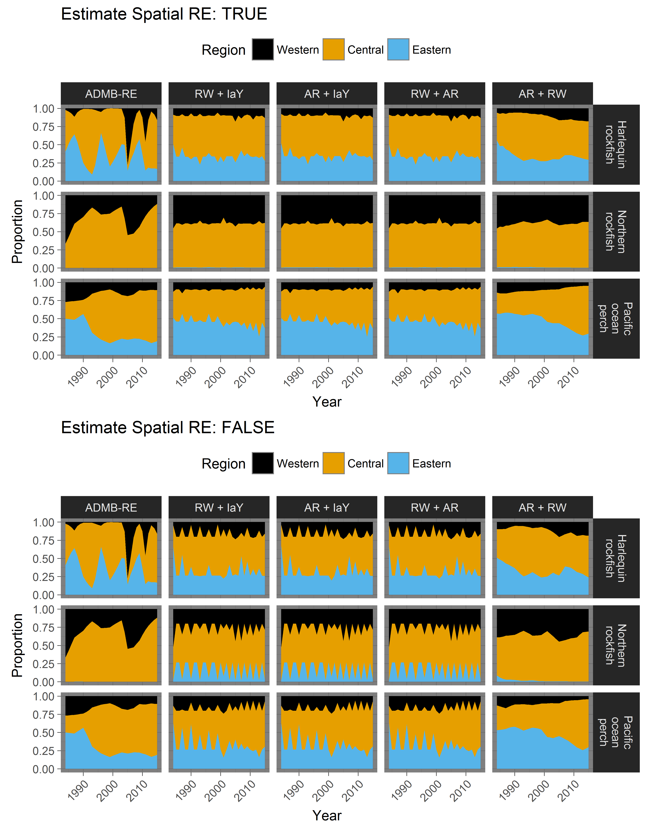Figure 9. Comparison of apportionment estimates from the ADMB-RE and stratified VAST models, for three rockfish species in the Gulf of Alaska. Model configurations are listed at top of the figure, with VAST model definitions listed in Table 5.

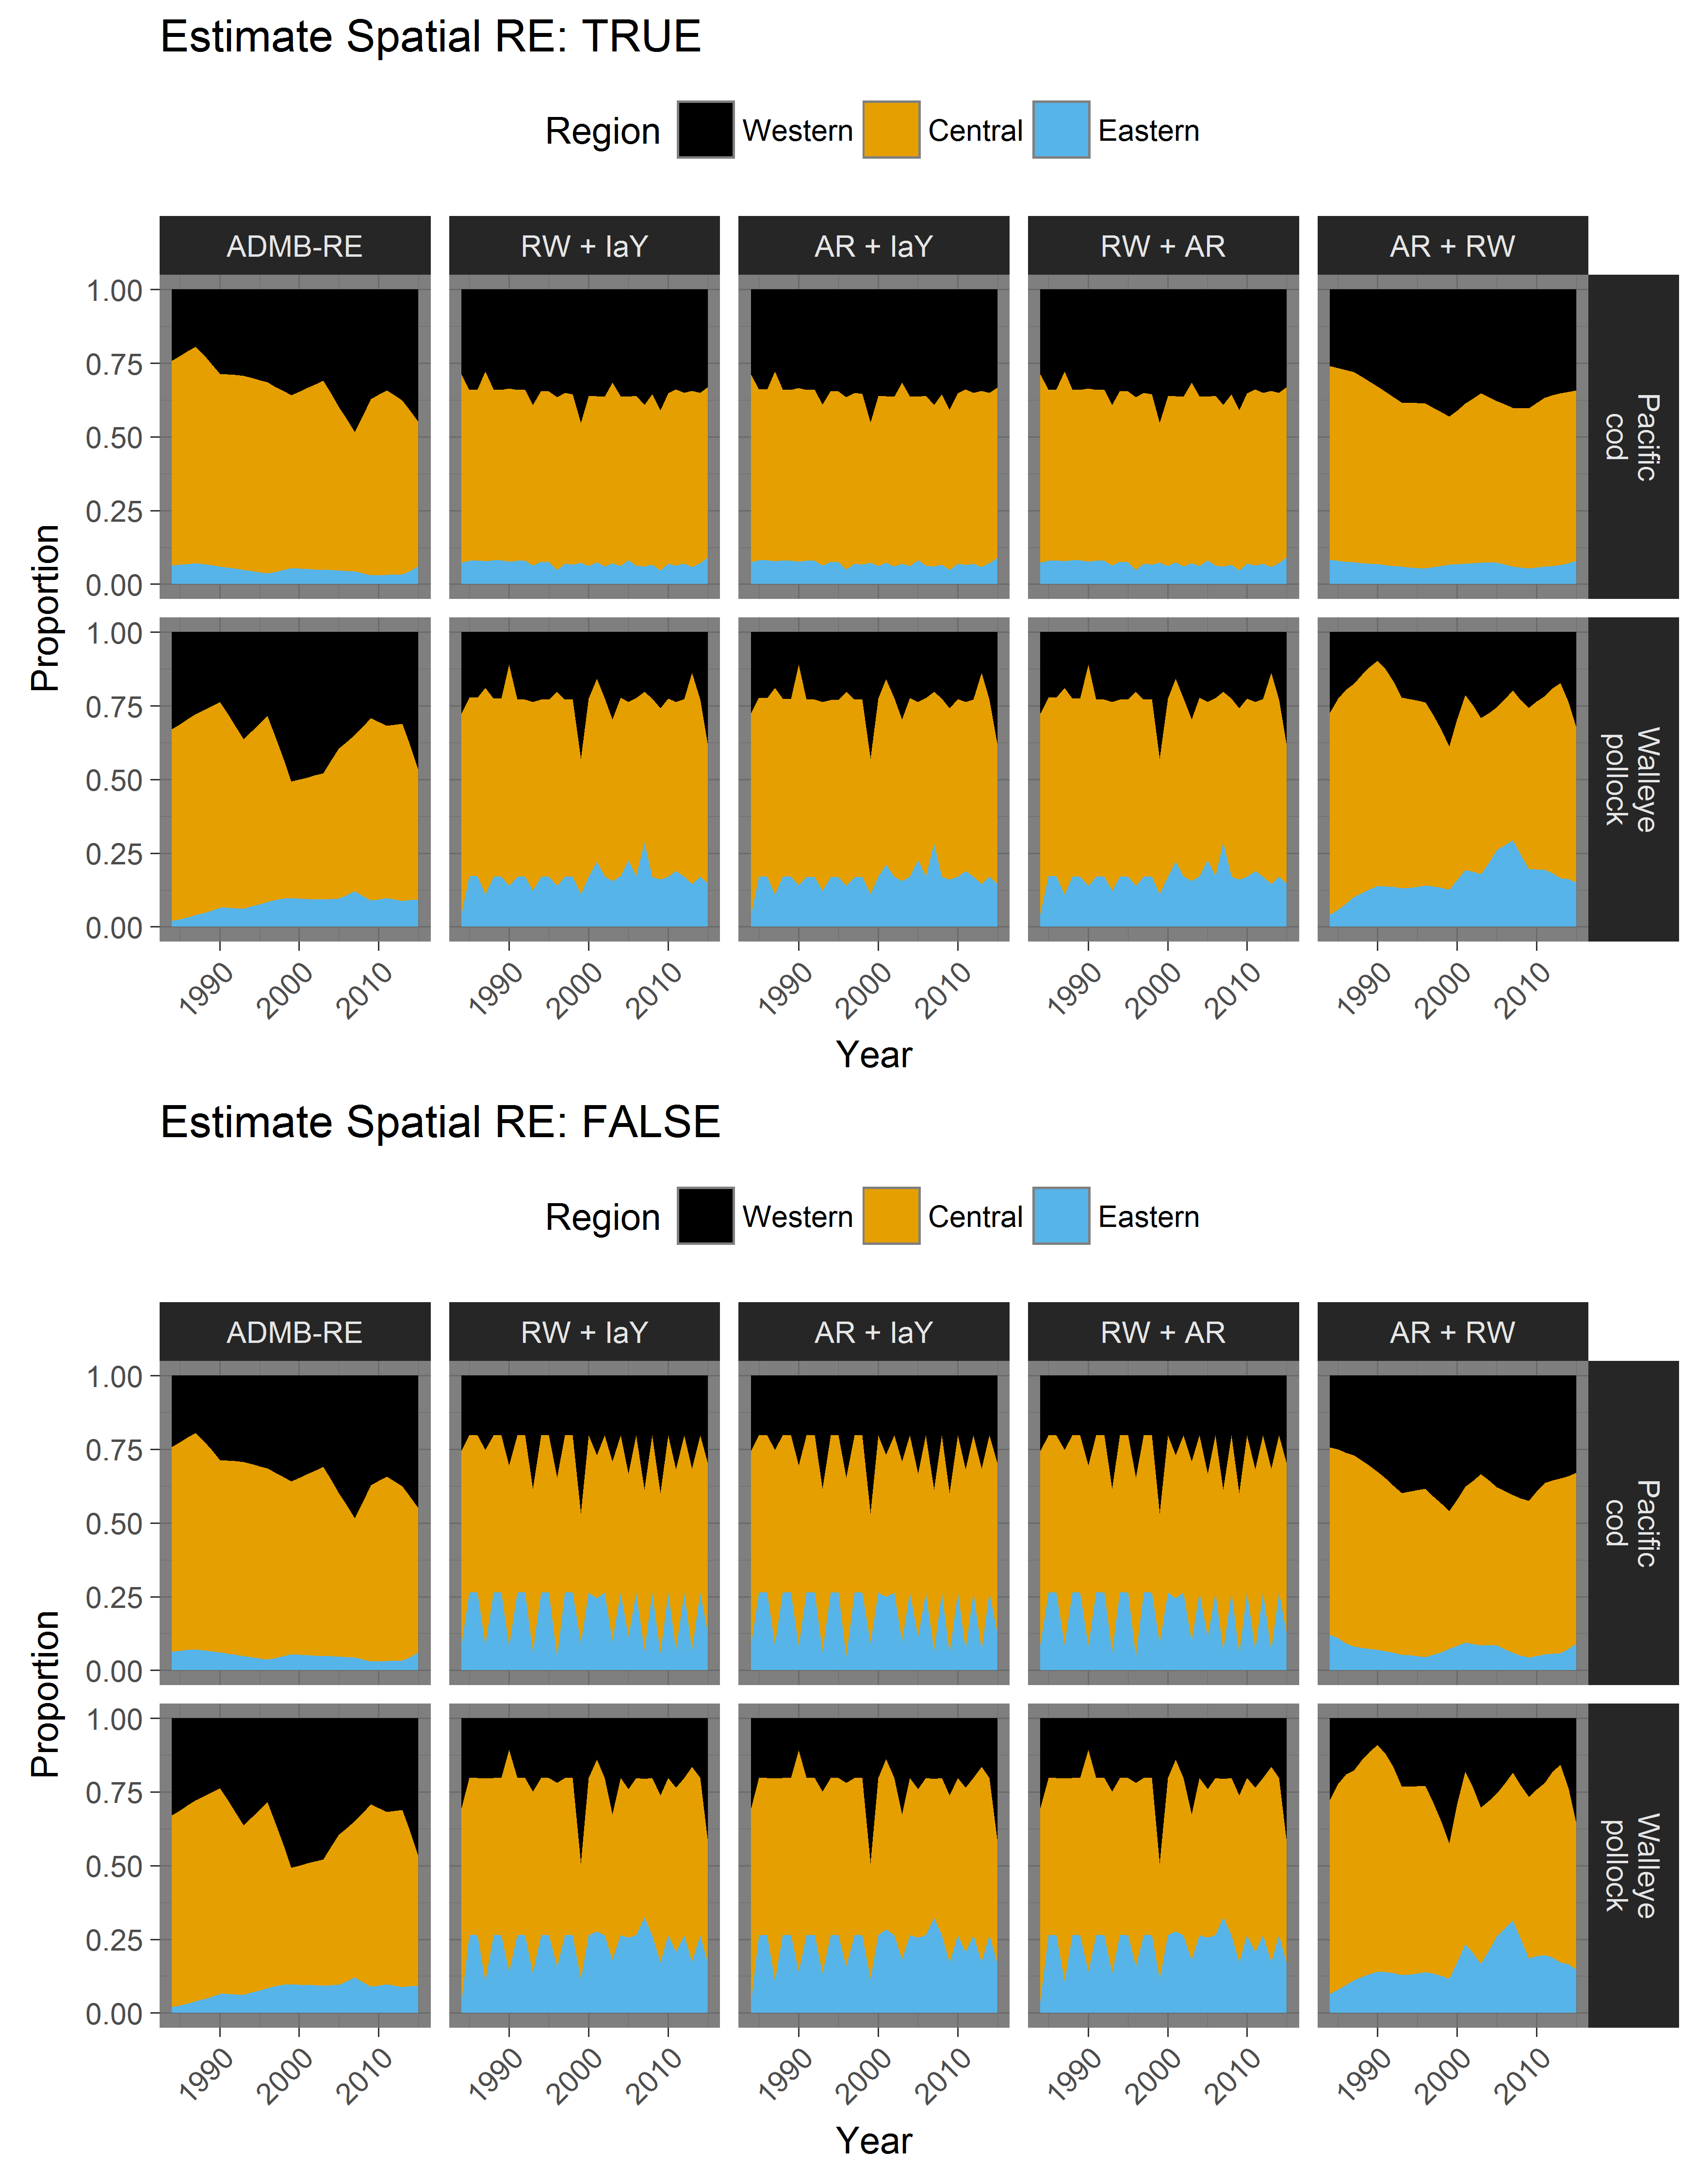Figure 10. Comparison of apportionment estimates from the ADMB-RE and stratified VAST models, for Pacific cod and Walleye pollock in the Gulf of Alaska. Model configurations are listed at top of the figure, with VAST model definitions listed in Table 5.

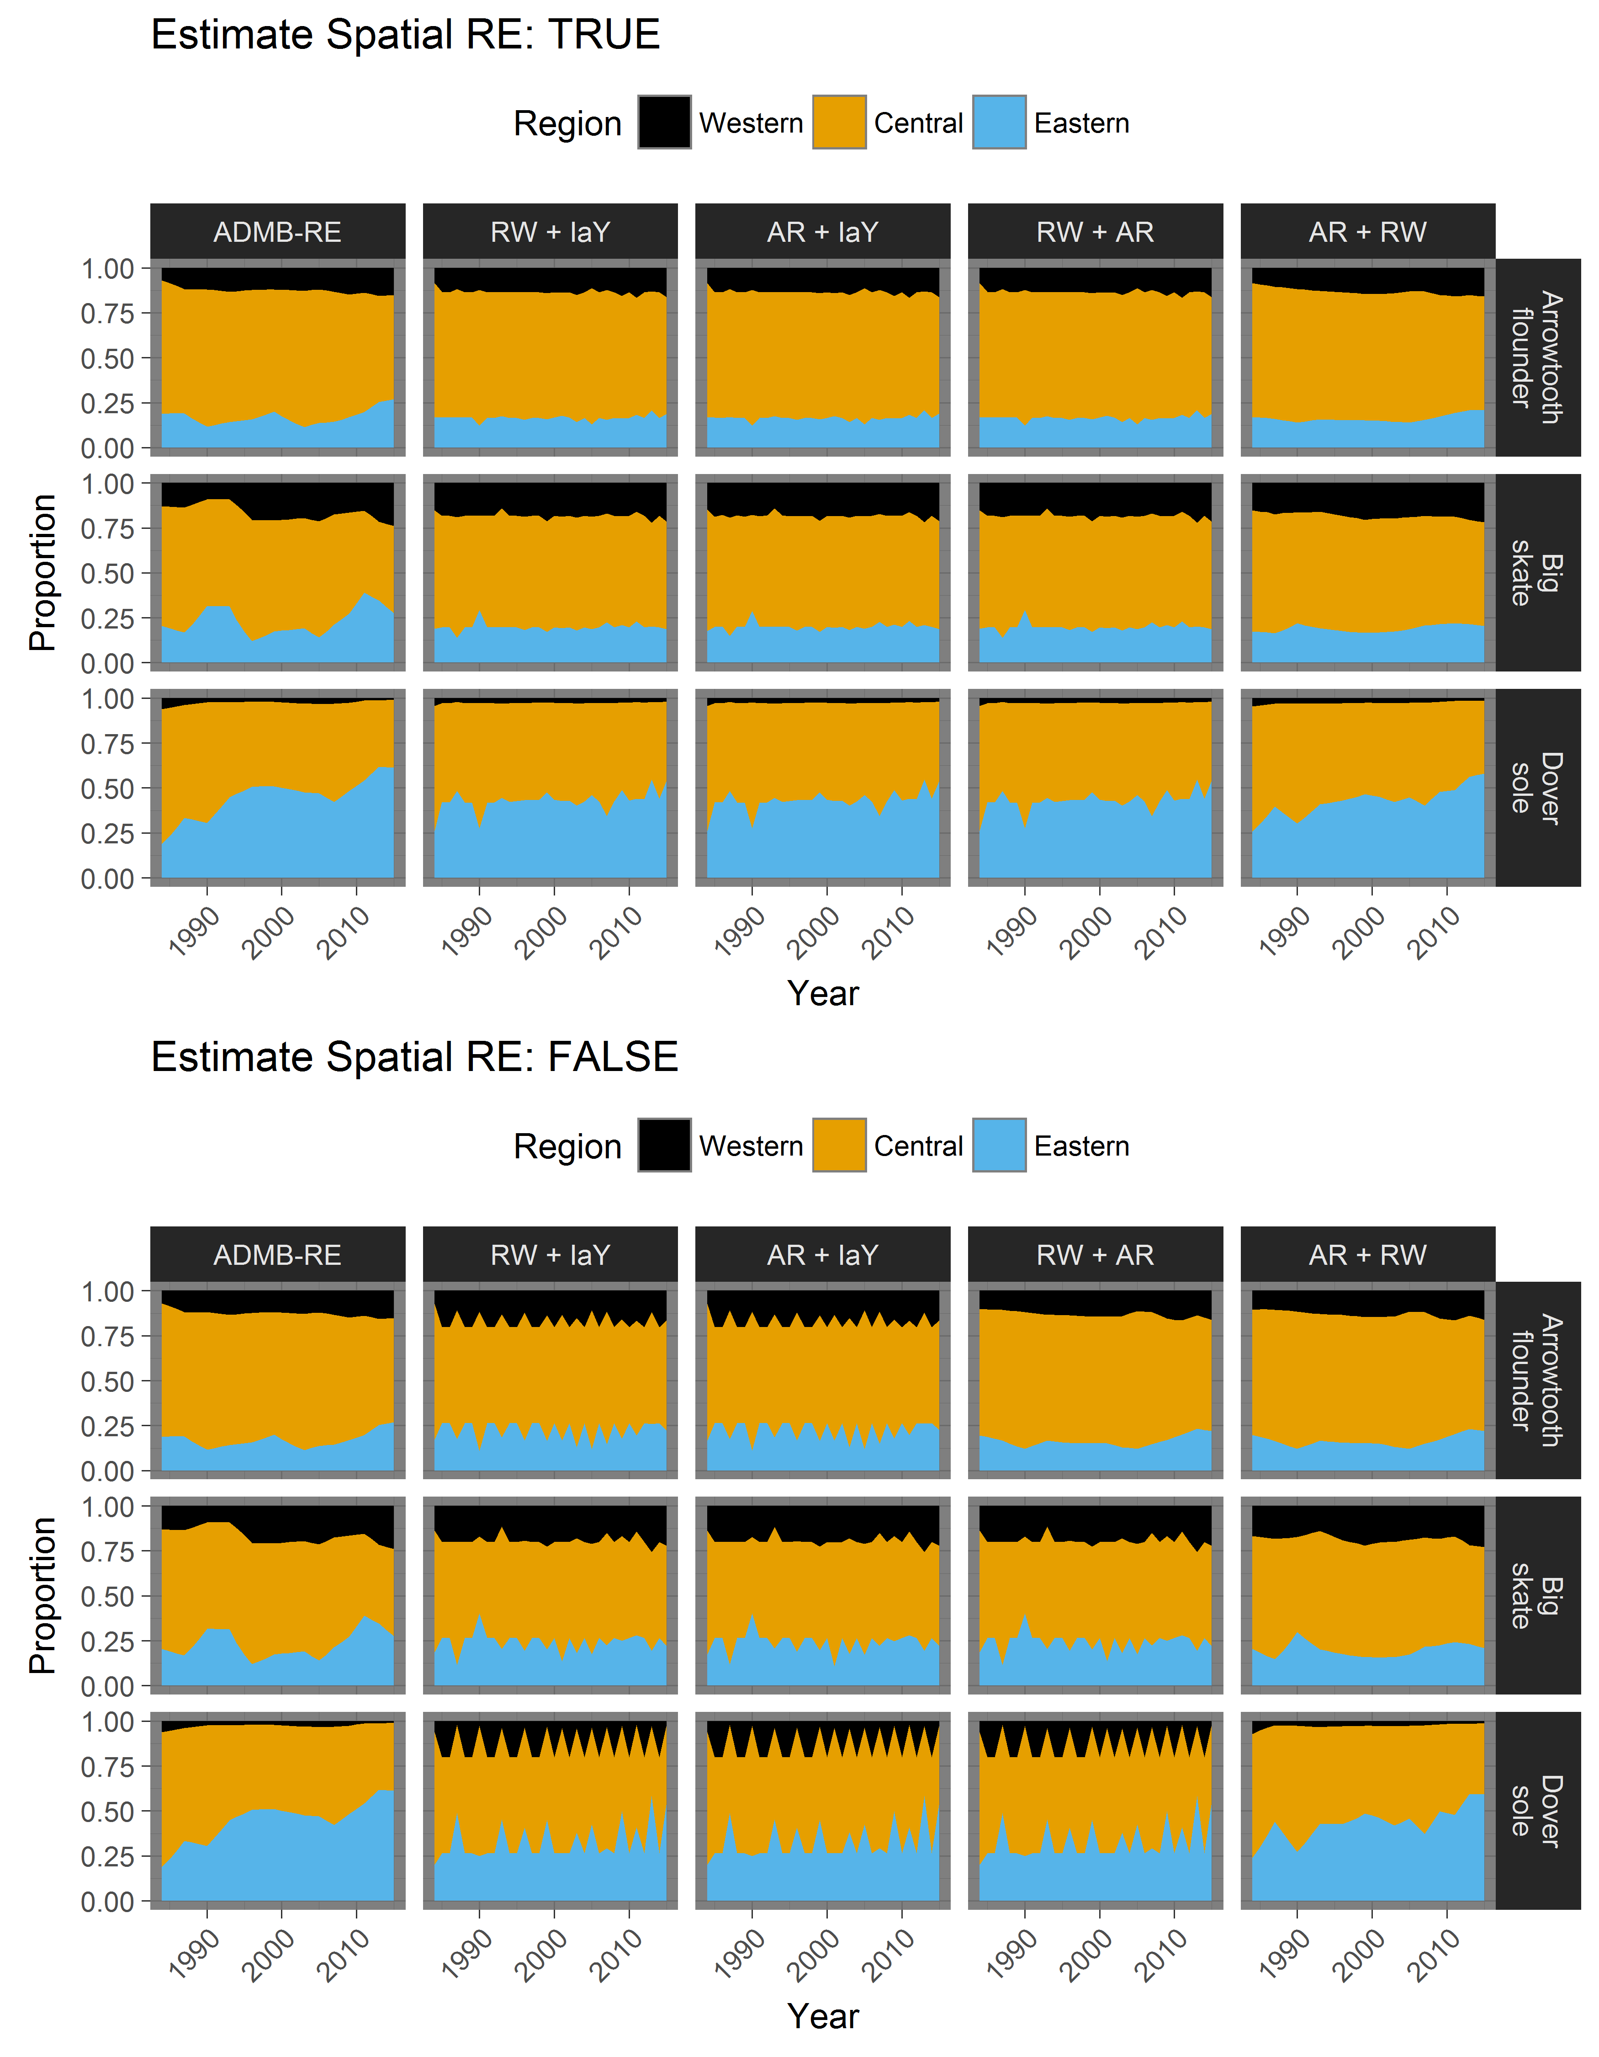Figure 11. Comparison of apportionment estimates from the ADMB-RE and stratified VAST models, for other species in the Gulf of Alaska. Model configurations are listed at top of the figure, with VAST model definitions listed in Table 5.

# References

Francis, R. I. C. C. 2011. Data weighting in statistical fisheries stock assessment models. Canadian Journal of Fisheries and Aquatic Sciences **68**:1124-1138.

Gertseva, V., and J. T. Thorson. 2013. Status of the darkblotched rockfish resource off the continental U.S. Pacific Coast in 2013. National Marine Fisheries Service, Northwest Fisheries Science Center, Fisheries Resource and Monitoring Division, Seattle, WA.

Kristensen, K., U. H. Thygesen, K. H. Andersen, J. E. Beyer, and J. M. Jech. 2014. Estimating spatio-temporal dynamics of size-structured populations. Canadian Journal of Fisheries and Aquatic Sciences **71**:326-336.

Maunder, M. N., and A. E. Punt. 2004. Standardizing catch and effort data: a review of recent approaches. Fisheries Research **70**:141-159.

Methot, R. D., G. R. Tromble, D. M. Lambert, and K. E. Greene. 2014. Implementing a science-based system for preventing overfishing and guiding sustainable fisheries in the United States. ICES Journal of Marine Science **71**:183-194.

Shelton, A. O., J. T. Thorson, E. J. Ward, and B. E. Feist. 2014. Spatial semiparametric models improve estimates of species abundance and distribution. Canadian Journal of Fisheries and Aquatic Sciences **71**:1655-1666.

Stefansson, G. 1996. Analysis of groundfish survey abundance data: combining the GLM and delta approaches. ICES Journal of Marine Science **53**:577-588.

Thorson, J. T., and L. A. K. Barnett. 2017. Comparing estimates of abundance trends and distribution shifts using single- and multispecies models of fishes and biogenic habitat. ICES Journal of Marine Science **75**:1311-1321.

Thorson, J. T., A. O. Shelton, E. J. Ward, and H. J. Skaug. 2015a. Geostatistical delta-generalized linear mixed models improve precision for estimated abundance indices for West Coast groundfishes. ICES Journal of Marine Science **72**:1297-1310.

Thorson, J. T., H. J. Skaug, K. Kristensen, A. O. Shelton, E. J. Ward, J. H. Harms, and J. A. Benante. 2015b. The importance of spatial models for estimating the strength of density dependence. Ecology **96**:1202-1212.

Thorson, J. T., I. J. Stewart, and A. E. Punt. 2011. Accounting for fish shoals in single- and multi-species survey data using mixture distribution models. Canadian Journal of Fisheries and Aquatic Sciences **68**:1681-1693.

Thorson, J. T., and E. J. Ward. 2014. Accounting for vessel effects when standardizing catch rates among cooperative surveys. Fisheries Research **155**:168-176.

Ver Hoef, J. M., and J. K. Jansen. 2007. Space—time zero-inflated count models of Harbor seals. Environmetrics **18**:697-712.

von Szalay, P. G., and N. W. Raring. 2016. Data report: 2015 Gulf of Alaska bottom trawl survey., U.S. Dep. of Commer.